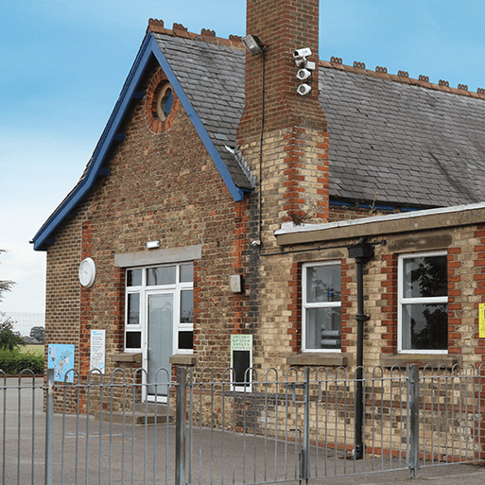
Our main topic this summer term in Year 1 is
School Days

In the School Days project, your child will have the opportunity to take part in a traditional Victorian class and will learn about the differences between schooling in the Victorian era and schooling today. They will learn about objects found in a Victorian classroom and how they were used. They will research Samuel Wilderspin, an important figure in the development of schooling for young children in the Victorian era, whose ideals are reflected in schooling today. They will learn to describe the passage of time through study of past, present and future tense vocabulary.
Maths
- Multiplication - count in 2s, 5s and 10s, recognise and add equal groups, make arrays and doubles.
- Division – make equal groups and share into equal groups.
- Fractions – find and recognise half and quarters of objects and quantities.
- Position and direction - Describe turns and use the terms left and right accurately, describe forwards, backwards, above and below.
- Place value to 100 – count from 50-100, tens to 100, partition into tens and ones, number lines to 100, 1 more 1 less, compare numbers.
- Money- know what each coin represents, recognising coins and notes, counting in coins.
- Time – Before and after, Days of the week, Months of the year, hours minutes and seconds, telling the time to the hour and half hour.
By the end of the project, these things will become our sticky knowledge (See knowledge organiser)
- The past describes a time before the present. The words ‘last’ and ‘ago’ are often used to explain when something happened in the past.
- The present describes the time now. The future describes a time that hasn’t happened yet.
- The word ‘next’ is often used to describe when something will happen in the future.
- A timeline shows information in chronological order.
- The Victorian era was the time from 1837 to 1901 when Queen Victoria was the monarch of the United Kingdom.
- Recall facts about Queen Victoria, the Industrial revolution, new inventions of significance, life for the rich and the poor and leisure time in the Victorian era.
- Know that reading, writing and arithmetic were called the three Rs. They were the most important lessons in Victorian schools alongside religious education.
- Talk about Victorian classrooms (class size, layout and equipment), teachers were strict and punishments included the cane.
- Samuel Wilderspin was a teacher who is known as the founder of infant education, he believed schools should be a happy place, and how he invented the school playground.

Literacy
- Learn to add the suffix er, est and ed to root words. For example- tall, taller, tallest.
- Proof read work and edit it.
- Use conjunctions such as and and but.
- Read and spell conjunctions, such as can’t, couldn’t and don’t.
- Use question marks and exclamation marks correctly.
- Know the ve spelling rule. Words ending in a v sound come with an e. For example- Have Gave Stove.
- Learn the plural s and es spelling rules. Add es to nouns ending in ch, sh, x, z, or s when they are plural.
- Use time adverbials- First, next, after that, secondly, lastly…
- Match rhyming words and continue a rhyming string.
- Write a poem.
- Write a diary entry.
- Produce a non-chronological report about plants.

Books we will be reading:

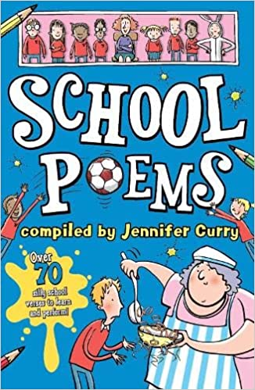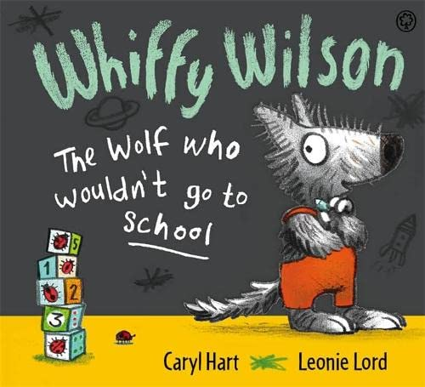

Science – Animal Parts
- We will learn that animals, including humans, can be sorted into six groups: amphibians, birds, fish, invertebrates, mammals and reptiles.
- We will learn that different animal groups have similar and different body parts and the purposes of these body parts.
- We will sort animals into the six animal groups based on characteristics. We will learn about pets and how they are cared for and identify the animal group for each.
- We will discuss what different animals eat, using the terms 'carnivore', 'herbivore' and 'omnivore', and observe the characteristic features of different animals that belong to these groups by examining their teeth and eye positions.
- Children will observe an invertebrate for a short period and ask scientific questions about the animal and research to find the answers.
Science – Plant Parts
- We will learn that plants are living things that grow from seeds or bulbs. We will revisit the concept of seasonal change, observing how trees and other plants change with the seasons, particularly from winter to spring.
- Observe, photograph and identify various plants growing in and around the school grounds.
- We will continue their learning by learning the parts of plants.
- We will explore where new plants come from and learn the names of some plants that grow from seeds and bulbs.
- We will learn about the parts of leaves, making comparisons, ask and answer scientific questions about the importance of plants to animals, including humans.
- Observe how a plant has changed over time and record their findings.
Phonics
In the first half of the term we will be consolidating our phonics knowledge and working on skills to apply our sticky knowledge when decoding new words. This is all in preparation for the Phonics Screening Test in June.
In the second half of the term we will be learning the following graphemes:-
- /ai/ eigh aigh ey ea – eight, straight, grey, break
- /n/ kn gn – knee, gnaw
- /m/ mb - thumb
- /ear/ ere eer – here, dear
- /zh/ su/ si – treasure, vision
- /j/ dge - bridge
- /i/ y - crystal
- /j/ ge - large
- /sh/ ti ssi si ci – potion, mission, mansion, delicious
- /or/ augh our oar ore – daughter, pour, oar, more

Personal, Social and Emotional Development – Relationships
- I can identify the members of my family and understand that there are lots of different types of families.
- I can identify what being a good friend means to me.
- I know appropriate ways of physical contact to greet my friends and know which ways I prefer.
- I know who can help me in my school community.
- I can recognise my qualities as person and a friend.
- I can tell you why I appreciate someone who is special to me.
Changing me
- I am starting to understand the life cycles of animals and humans.
- I can tell you some things about me that have changed and some things about me that have stayed the same.
- I can tell you how my body has changed since I was a baby.
- I can identify the parts of the body that make boys different to girls.
- I respect my body and understand which parts are private.
- I understand that every time I learn something new I change a little bit.
- I can tell you about changes that have happened in my life.

Art and Design – Street view
- This project teaches children about artwork depicting streets and buildings and focuses on the work of the American pop artist, James Rizzi. They create a 3-D mural based on Rizzi's work.
Design and Technology – Chop, Slice, Mash.
- This project teaches children about sources of food and the skills of peeling, tearing, slicing, chopping, mashing and grating. They use this knowledge and techniques to design and make a supermarket sandwich according to specific design criteria.

PE
PE days will be
Miss Miller’s class – Wednesday and Thursday
Mrs Drayton’s class – Thursday and Friday
As the weather gets warmer we will move our lessons outside, so please ensure your child is in trainers and has a jumper in school, as it can get chilly outside even on warmer days.
Striking and Fielding
- I can catch a beanbag and a medium sized ball.
- I can roll a ball towards a target.
- I can strike a ball using my hand.
- I can track a ball that is coming towards me.
- I know how to score a points.
- I understand rules and I’m beginning to use these to play honestly and fairly.
- I understand when I am successful.
Net and Wall
- I can hit a ball using a racket.
- I can throw a ball over a net to land in a given space.
- I can track equipment sent to me.
- I know how to score points.
- I show honesty and fair play when playing an opponent.
- I recognise changes to my body.
Target
- I can recognise changes to my body.
- I can use an overarm throw to aim for a target.
- I can roll a ball towards a target.
- I can use an underarm throw to aim for a target.
- I can work co-operatively with a partner.
- I can recognise good technique.
Athletics – Sports Day preparation
- I am able to throw towards a target.
- I am beginning to show balance and co-ordination when changing directions.
- I am developing overarm throwing.
- I can recognise changes to my body.
- I can run at different speeds.
- I can work with others to make safe choices.
- I try my best.
- I understand the difference between a jump, leap and hop and which is best to achieve a given goal.

Supporting your child at home
- Whilst we continue to hear your child read in
school, it is essential that your child reads frequently at home. Please hear your child read at least 3 times a week and sign their reading record. Reading each book more than once helps to develop their fluency and comprehension of the texts.
- When we individually hear your child read we
also check the key words they have been practising reading and spelling at home. If they get all/most correct, then new words are issued. Books are changed on a Monday and when we hear them individually read if required. If your child moves onto Phase 6 books then they can change their own books whenever they have read them themselves.
- Please remember you can support phonics at
home via the free games available on www.phonicsplay.co.uk We are currently learning Phase 5 sounds.

- Spend time counting from different numbers
and writing different numbers.
- Learn 2x, 5x, 10x tables.
- Spend time looking at coins and their value.
- Practise telling the time to the hour and half
hour
- Please remember you can support maths skills
at home via the free games available on www.topmarks.co.uk. There is also a free app that works alongside the scheme of work we are using with short fun activities. Search in your app store (itunes, google or kindle) for 1 minute maths.

Useful websites
- BBC Primary History – Education and life in the Victorian classroom
- BBC Primary History – A Victorian Board School
- CBBC – The students get a Victorian schooling
- BBC Bitesize – Who was Queen Victoria?
- DKfindout! – Victorian Britain – Victorian Facts
- Museum of London – What was life like for children in Victorian London?
- Wilderspin National School – Samuel Wilderspin

Please continue to check our teams pages regularly, as we will be sending messages and setting weekly homework through these.

In order to try to save the planet and reduce our paper usage, we as a school will be uploading more letters to our website, which is accessible to you all. www.bushfieldinfants.co.uk
Computing.
In computing we will be looking at basic computer programming using ScratchJr.
We will explore tinkering with a basic animation and then working on a project of our own. We will then move onto learning how to do basic debugging of a computer programme, looking at why it does not do what it should and how to fix it.

