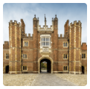
Our main project in Year 2 this half term is
Magnificent Monarchs
We will be finding out about the English and British monarchy from AD 871 to the present day. Using timelines, information about royal palaces, portraits and other historical sources, we will build up an understanding of the monarchs and then research six of the most significant sovereigns.

Maths
- To recognise fractions- whole, half, quarter, third
- Know unit and non-unit fractions- recognise the equivalent of half and two quarters, recognise and find three quarters
- Mixed addition, subtraction, division and multiplication
- To make the same amount in different ways
- To compare amounts
- To calculate with money
- To make totals and find the change
- SATs revision and SATs papers
Sticky Knowledge

- What is Monarchy?
- Monarchy in the United Kingdom.
- Power of the Monarchy.
- Royal Residences.
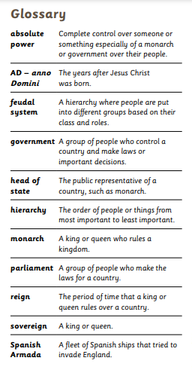

English/Phonics
- To write for different purposes- glossary, fact file, diary entries, character/setting descriptions, riddle writing and recounts
- To answer retrieval, inference and deduction questions
- To identify sentences with different forms; statement, question, exclamation, command
- Spell HFW homophones, including would, should, could
- Investigate and spell compound words
- SATs practise and real SATs
- Books we will be reading: Queen Victoria’s Bathing Machine by Gloria Whelan, The Cook and the King by Julia Donaldson, The Pea and the Princess by Mini Grey

Science
- Know that objects, materials and living things can be looked at, compared and grouped according to their features
- Recap habitats and microhabitats
- Know that invertebrates have no backbone and examples
- Know that animals need water, food, air and shelter to survive within their habitats
- Learn about food chains and how they always start with a plant
- Collect, record and display data in different ways
Communication, Language and Literacy

- Phase 1 Phonics – identifying different instrumental sounds and making sounds with different instruments.
- Writing our name.
- Talking about our favourite stories.
- Listening and responding to a variety of stories including Jack and the Beanstalk, Cinderella and the Little Red Hen.
- Looking at Good and Bad characters in stories.

Knowledge and Understanding of the World

- Investigating what plants need to grow.
- Making and tasting pancakes.
- Finding out about Easter and how it is celebrated.
- Using the internet to play games and mouse control activities.
Creative Development

- Singing Nursery Rhymes and action songs
- Making crowns.
- Making friendship bracelets
- Making cards
- Creating Easter Crafts

Inspiration Day

Tuesday 25th February – My Favourite Book
Can your child bring their favourite book to school to show and talk about? We will also be having a Prince and Princess Picnic in the afternoon. Your child does not need to dress up on this day.

Key Dates
SATs
- Spelling, Punctuation and Grammar – 2nd and 3rd May.
- Reading - 9th and 11th May.
- Maths – 15th and 17th May.
- Gainsborough Old Hall visit – 22nd May
- Leavers Concert – 17th & 18th July

Colour Monster - Anna Llenas
Elmer - David McKee.

History
We will be researching the following six significant Monarchs.
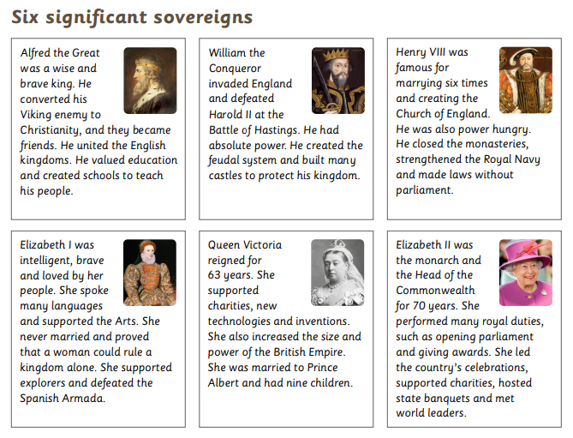
RE- Jumu’ah LTC
This topic will look at various aspects of Islam- Friday prayers, Bilal, mosque models and visits, exploring worship.

PE Striking and Fielding
In this topic we will be learning to track a rolling ball and collect it, improve underarm throwing/catching accuracy to field then limit a batter’s score, develop hitting for distance to score more points and develop decision making to get a batter out/under pressure.
Net and wall games
Here we will be able to use the ready position to defend a space, return a ball with hands, play against a partner, develop racket skills and use them to return a ball and return a ball using a racket.
Art and Design- Portraits and Poses
In this topic we will be learning many skills- how to analyse paintings, sketch a pose, draw digitally and investigate portraiture (including royal).

Computing
We will be learning how to stay safe online as well as algorithms, programming/debugging and using data.
PSHE- Relationships
In this topic we will think about the relationship with family members and sharing-cooperation, understand the types of physical contact and what is acceptable or not, identifying and resolving conflicts with friends, knowing when it is good to keep a secret or not, recognising and appreciating the people who help us, as well as expressing and accepting appreciation from those in our special relationships.
Supporting your child at home
Go to BBC Bitesize for helpful revision hints and tips in preparation for the SATs with fun games, activities and much more. https://www.bbc.co.uk/bitesize/articles/zrybvk7
https://www.primarytools.co.uk/ks1-year-2-sats-papers/ is a site where you can also download and print off past SATs papers to practise at home.
Visit https://www.topmarks.co.uk/maths-games/hit-the-button to help your child with their mental maths by playing a variety of games.
Find out more about our Kings and Queens on https://www.bbc.co.uk/bitesize/topics/zkrkscw by exploring the videos and games together.

