BUSHFIELD ROAD INFANT SCHOOL
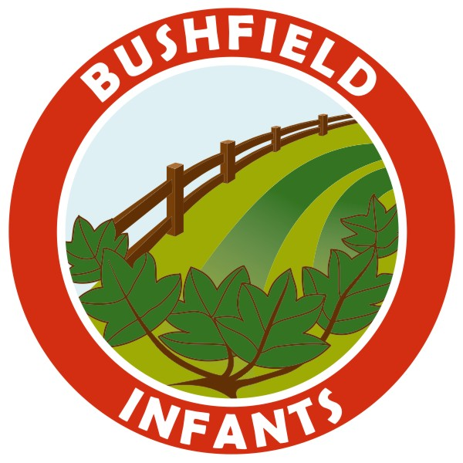
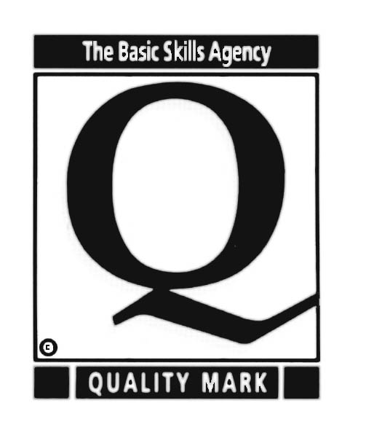
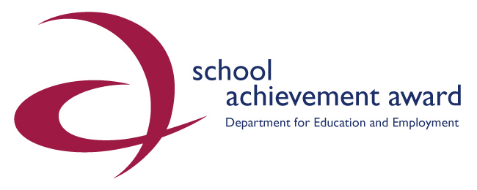
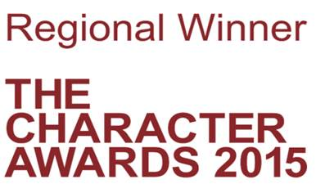
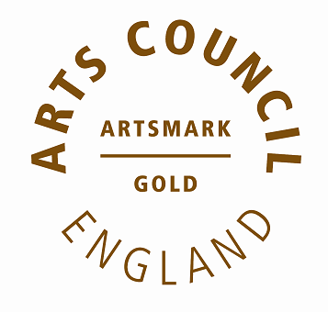

______________________________________________________________________________________________
HEAD TEACHER: Mrs T Bass BA PGCE NPQH
______________________________________________________________________________________________ Telephone No: (01724) 842829 BUSHFIELD ROAD
Fax No: (01724) 842829 SCUNTHORPE
NORTH LINCOLNSHIRE
DN16 1NA

September 2021

Dear Parents/Carers/Guardians,

Is your child eligible for Pupil Premium Funding?

Currently pupils in Reception, Year 1 and Year 2 are all entitled to a free school meal, which is paid for by government funding. This provision is called Universal Free School Meals or UFSM.

In addition to this universal funding, parents in low income families or those that are unemployed can also apply for Pupil Premium and their child’s school receive extra funding from central government. Schools use this funding to fund valuable support like extra tuition, learning assistants and after school clubs. Children can then also receive free school meals in subsequent school years. (Year 3 and onwards) In addition to the above support, you will also receive a £20 grant to help with the cost of your child's school uniform on your first claim.

For every child registered, Bushfield Road Infant School receives £1,345 per year. This additional funding allows us to provide an even better education for your child through the purchase of additional resources, staff to support learning and curriculum enrichment opportunities.

Are you eligible?

You can register your child for Pupil Premium (and free school meals for Year 3 onwards) if you receive any of the following:

- Income Support
- Income-based Jobseeker’s Allowance
- Income-related Employment and Support Allowance
- Support under Part VI of the Immigration and Asylum Act 1999
- The guaranteed element of Pension Credit
- Child Tax Credit (provided you’re not also entitled to Working Tax Credit and have an annual gross income of no more than £16,190)
- Working Tax Credit run-on - paid for 4 weeks after you stop qualifying for Working Tax Credit
- Universal Credit - if you apply on or after 1 April 2018 your household income must be less than £7,400 a year (after tax and not including any benefits you get)

Children who get paid these benefits directly, instead of through a parent or guardian, can also get free school meals.

Eligibility for NURSERY FREE SCHOOL MEALS and PUPIL PREMIUM

Your child may also get free school meals if you get any of the above benefits and your child is both:
- younger than the compulsory age for starting school
- in full-time or part-time education

No one will know you have registered and it will not affect any other benefits you are claiming.

Please bear in mind you may become eligible at any time when your child is of school age if your working circumstances change, for example, if you are made redundant or become a single parent, and you may be able to register your child for Pupil Premium.

If you think you would be eligible for Pupil Premium you can:
- apply online at www.northlincs.gov.uk
- enquire at any Council Local Link Office
- telephone 01724 297217 for a paper form to be posted directly to you.

In addition you can also speak to school office staff or Mrs Hill our Learning Mentor for advice and support.

Even if you don’t want your child to have a free school meal and you provide a packed lunch, as long as you qualify and register, school will receive the Pupil Premium funding.

Special Guardianship/Adoption/Armed Forces Service Children

In addition, schools also receive Pupil Premium funding for children who have left Care and are Adopted, cared for under a Special Guardianship Order or a Residence Order. The school also receives Service Premium for children of Armed Forces Service Personnel. In any of the above cases please contact school directly to register your child. You will need to show evidence and all information will be treated confidentially.

Mrs T Bass
Head Teacher

