**Year 1 Summer term project. This term our learning is focused on Knights and Castles, Jack and the Beanstalk and Growing Plants.**

**Science** [www.twinkl.co.uk](http://www.twinkl.co.uk) Resources included here

* Keep a weather diary. Include the day and date, the weather in the morning and afternoon.
* Grow a plant or learn about the growth of a plant using Twinkl or YouTube. Complete the life cycle.
* Watch the Parts of a plant PowerPoint and then draw a flower/plant and label the stem, roots, petals, leaves.

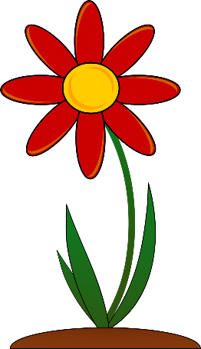

**Art and Design** Resources included

* Design your own shield. Template included. You can use the examples sheet to help you.

Can you turn your design into an actual shield using cardboard and things around the house?

* Design a plant pot – ideas for decorating it could be things you see in the garden: flowers and mini beasts.
* Design a new pair of socks for Sir Charlie Stinky Socks.
* Make a castle out of boxes or Lego.

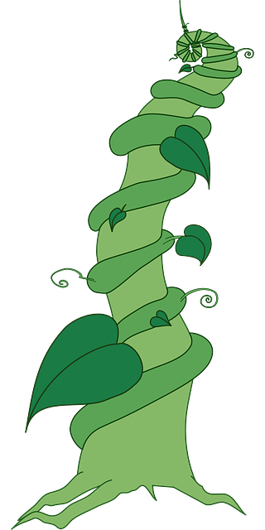

**English** [www.twinkl.co.uk](http://www.twinkl.co.uk) Resources included

* Read the Jack and the Beanstalk

e-book. <https://www.twinkl.co.uk/resource/jack-and-the-beanstalk-ebook-tp-l-52314>

Then retell the story – if you need some bits and bobs then use the writing activity attached to help you.

There is also a sequence the story activity you can do.

* Using YouTube listen to one of the Sir Charlie Stinky Socks stories. Can you write some instructions to help Sir Charlie learn how to wash his stinky socks?
* Step inside the picture – using the picture of the castle attached tell me what you can see, hear and smell. Remember to add details to your sentences with describing words.

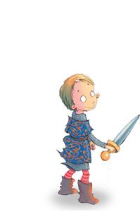

History [www.twinkl.co.uk](http://www.twinkl.co.uk) Resources included

* Motte and Bailey castle

PowerPoint – work through the

PowerPoint with a grown up to

help you.

* Label a castle activity.

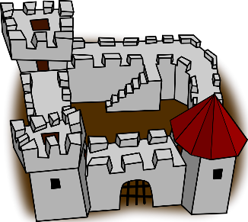

**Maths** [www.twinkl.co.uk](http://www.twinkl.co.uk) Resources included

* Castle number work – filling in the missing numbers on the 100 square or the 0-20 wall, use the 100 square to help you count in 2s, 5s and 10s. See below
* Plants colour by numbers subtraction (up to 10 or 20). Work out the answers to the sums and then follow the colour key to colour your flower.
* What’s the time Mr Wolf games – practice telling the time to the hour and the half hour. <https://www.twinkl.co.uk/resource/tg-ga-178-whats-the-time-mr-wolf-game>
* Double the spots – remember there must be the same number of spots on both sides of the ladybird.
* Fractions - Colour half the shapes and find half the amounts using the dominoes.
* Turns – use the pictures to show ¼ and half turns.

**Step inside the picture.**

Think about our work from the Great Fire of London.

[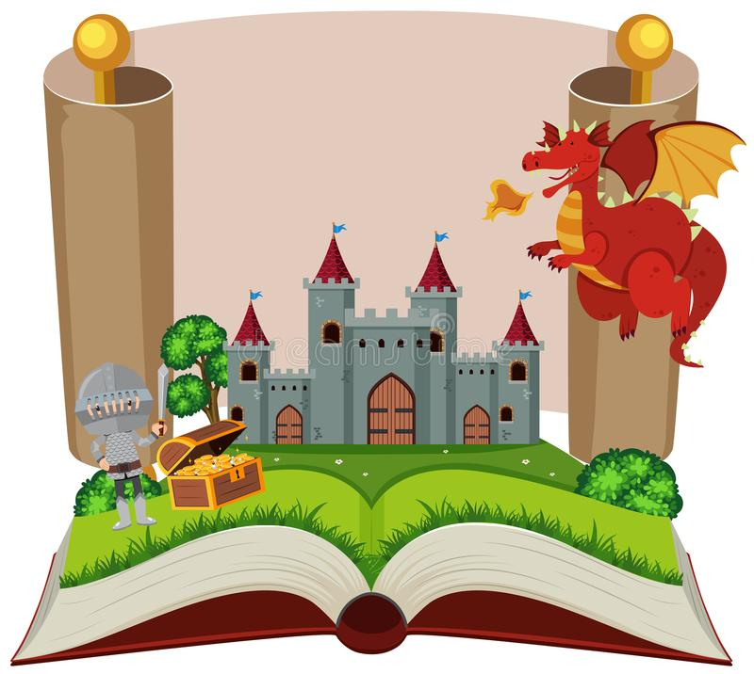](https://www.google.com/url?sa=i&url=https://www.dreamstime.com/illustration/storybook-castle.html&psig=AOvVaw2MEO34J4rBoXBPUftSZiaM&ust=1589459825884000&source=images&cd=vfe&ved=0CAIQjRxqFwoTCJDU-dHssOkCFQAAAAAdAAAAABAK)Start your sentences using

I can see …

I can hear …

I can smell …

I can feel …

**Jack and the Beanstalk Writing Activity**

Write a sentence about each of the story pictures. Use the boxes at the top to help you.

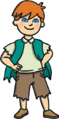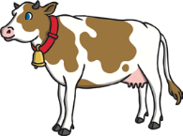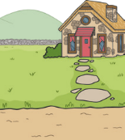

**cottage**

**cow**

**Jack**

**magic beans**

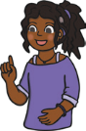

sound talk

finger spaces

full stop

___________________________________________________________________________________________________________________________________________________________________________________________________________________________________________________________________________________________________________________________________________________________________________________________________________________________________________________________________________________________________________________________________________________________________________________________________________________________________

___________________________________________________________________________________________________________________________________________________________________________________________________________________________________________________________________________________________________________________________________________________________________________________________________________________________________________________________________________________________________________________________________________________________________________________________________________________________________

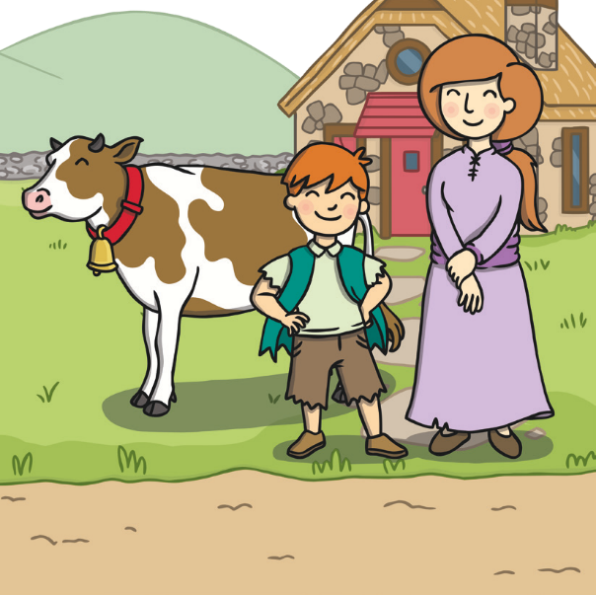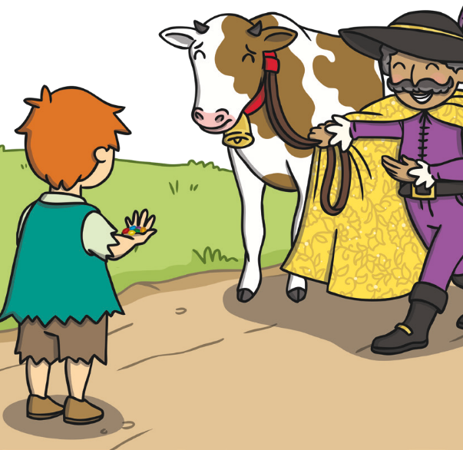

**Jack and the Beanstalk Writing Activity**

Write a sentence about each of the story pictures. Use the boxes at the top to help you.

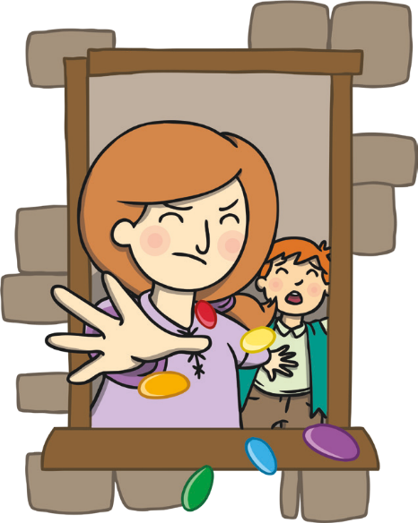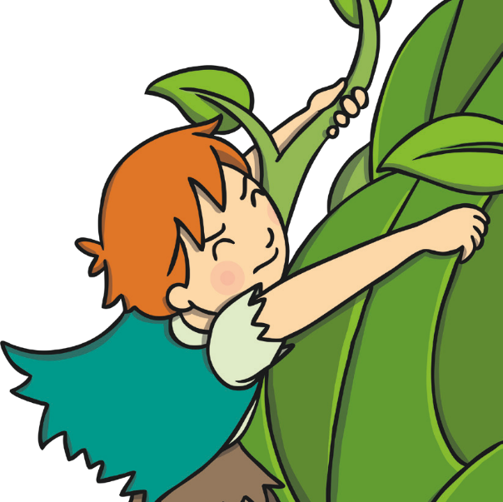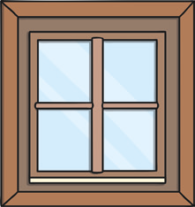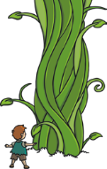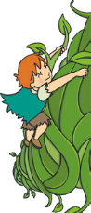

**magic beans**

**window**

**climb**

**beanstalk**



sound talk

finger spaces

full stop

___________________________________________________________________________________________________________________________________________________________________________________________________________________________________________________________________________________________________________________________________________________________________________________________________________________________________________________________________________________________________________________________________________________________________________________________________________________________________

___________________________________________________________________________________________________________________________________________________________________________________________________________________________________________________________________________________________________________________________________________________________________________________________________________________________________________________________________________________________________________________________________________________________________________________________________________________________________

**Jack and the Beanstalk Writing Activity**

Write a sentence about each of the story pictures. Use the boxes at the top to help you.

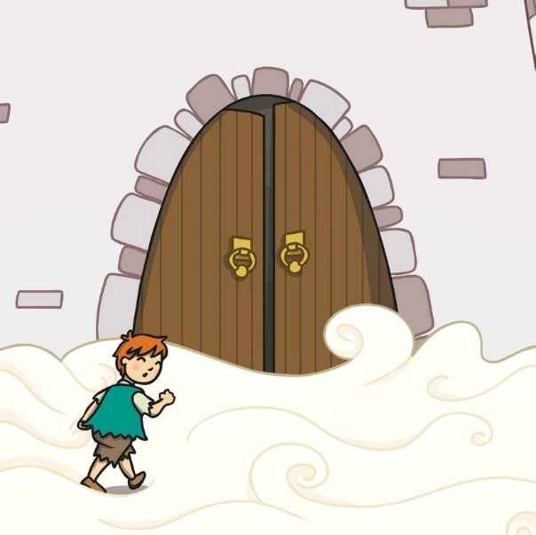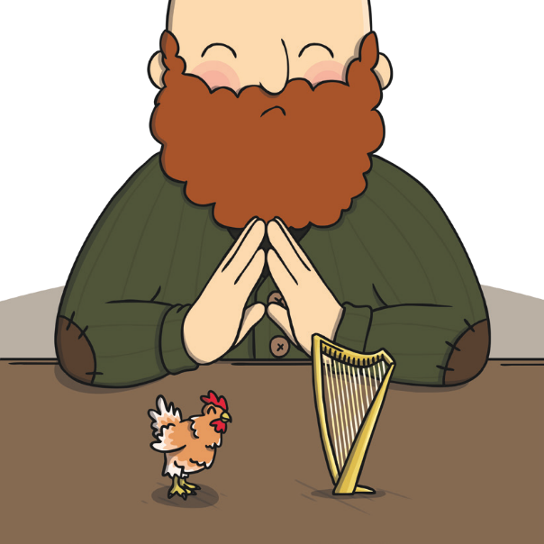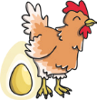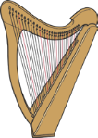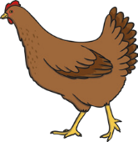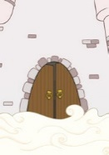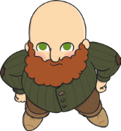

**castle**

**giant**

**hen**

**golden egg**

**harp**



sound talk

finger spaces

full stop

___________________________________________________________________________________________________________________________________________________________________________________________________________________________________________________________________________________________________________________________________________________________________________________________________________________________________________________________________________________________________________________________________________________________________________________________________________________________________

___________________________________________________________________________________________________________________________________________________________________________________________________________________________________________________________________________________________________________________________________________________________________________________________________________________________________________________________________________________________________________________________________________________________________________________________________________________________________

**Jack and the Beanstalk Writing Activity**

Write a sentence about each of the story pictures. Use the boxes at the top to help you.

___________________________________________________________________________________________________________________________________________________________________________________________________________________________________________________________________________________________________________________________________________________________________________________________________________________________________________________________________________________________________________________________________________________________________________________________________________________________________

___________________________________________________________________________________________________________________________________________________________________________________________________________________________________________________________________________________________________________________________________________________________________________________________________________________________________________________________________________________________________________________________________________________________________________________________________________________________________

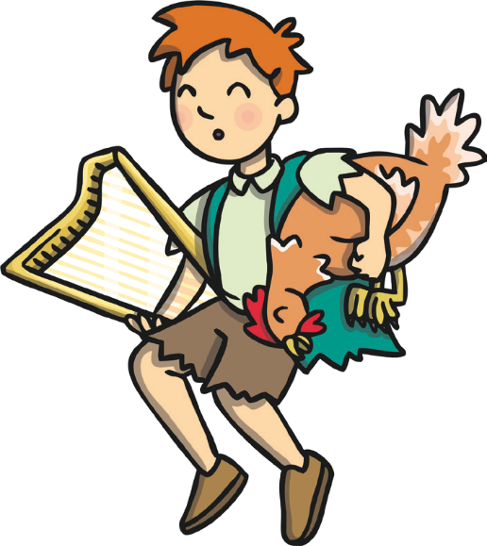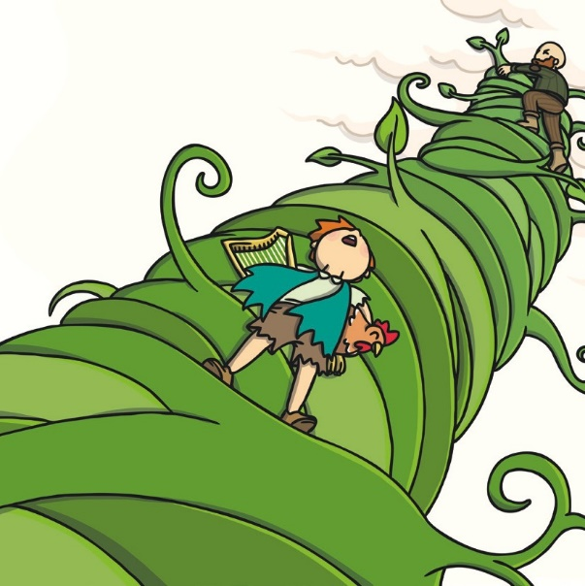

**giant**

**hen**

**harp**

**beanstalk**



sound talk

finger spaces

full stop

**Jack and the Beanstalk Writing Activity**

Write a sentence about each of the story pictures. Use the boxes at the top to help you.

___________________________________________________________________________________________________________________________________________________________________________________________________________________________________________________________________________________________________________________________________________________________________________________________________________________________________________________________________________________________________________________________________________________________________________________________________________________________________

___________________________________________________________________________________________________________________________________________________________________________________________________________________________________________________________________________________________________________________________________________________________________________________________________________________________________________________________________________________________________________________________________________________________________________________________________________________________________

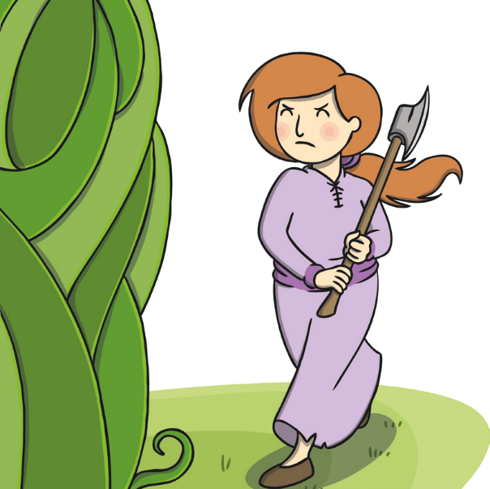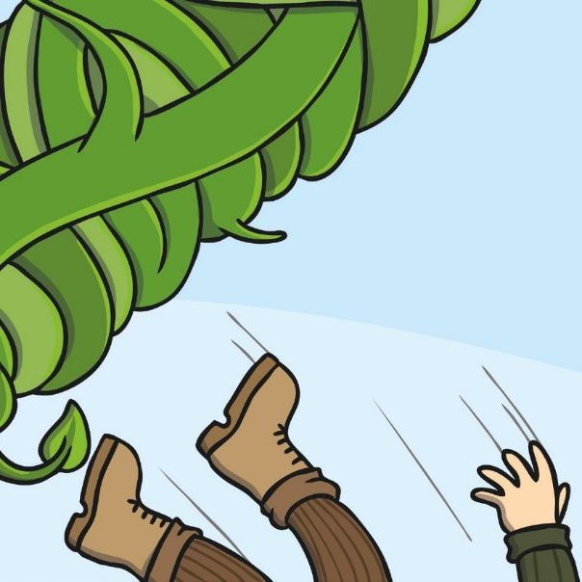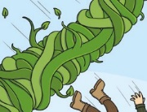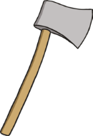

**axe**

**beanstalk**

**giant**

**fell**



sound talk

finger spaces

full stop

Can you fill in the missing numbers?



|  |  |  |  |  |  |  |  |  |  |
| --- | --- | --- | --- | --- | --- | --- | --- | --- | --- |
| 1 | 2 |  | 4 | 5 | 6 | 7 | 8 | 9 | 10 |
| 1 1 | 12 |  | 14 |  | 16 | 17 |  | 19 | 20 |
|  | 22 |  | 24 | 25 |  |  | 28 |  | 30 |
| 31 | 32 |  |  | 35 | 36 | 37 |  | 39 | 40 |
| 41 | 42 | 43 |  |  |  |  |  | 49 | 50 |
| 51 | 52 |  | 54 | 55 |  | 57 | 58 | 59 | 60 |
| 61 | 62 |  |  | 65 | 66 |  |  | 69 |  |
|  | 72 |  | 74 |  | 76 | 77 | 78 | 79 | 80 |
|  | 82 |  | 84 | 85 | 86 |  |  | 89 | 90 |
|  | 92 | 93 | 94 | 95 | 96 |  | 98 |  | 100 |

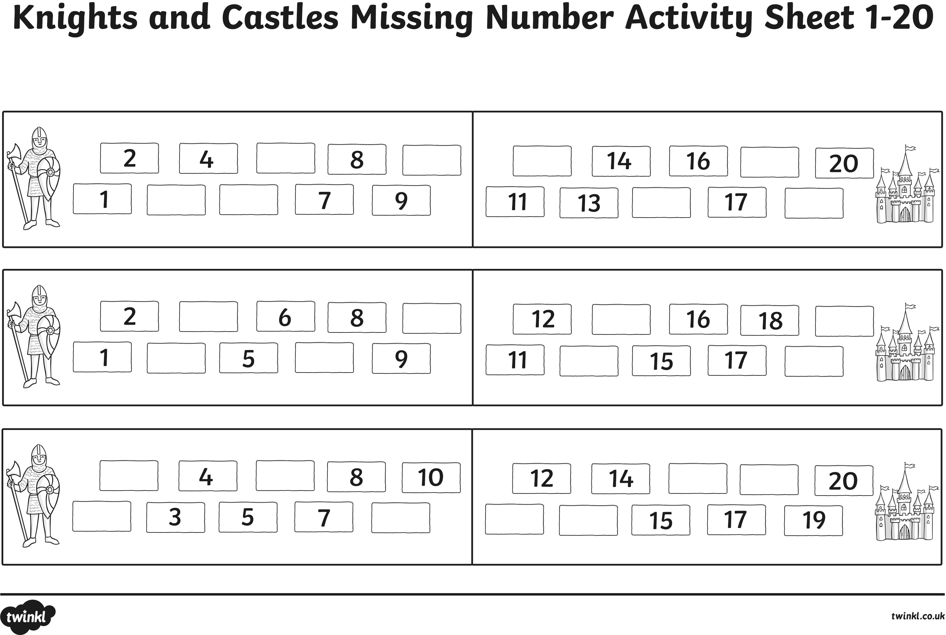

**Ladybird Doubles**

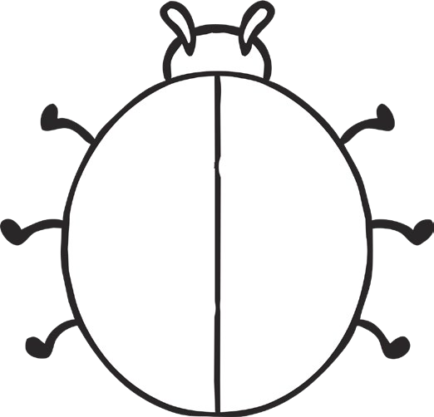

Double 1 is Double 2 is



Double 3 is Double 4 is



Double 5 is Double 6 is _______





Double 7 is __________ Double 8 is ________















Double 9 is _____________ Double 10 is _______

Colour in **half** of these shapes.

Halve the dominoes.

Half of 2 is _________ Half of 4 is _________

Half of 6 is ___________ Half of 8 is ____________

Half of 10 is _______________ Half of 12 is ____________

Halve the dominoes p2

Half of 14 is ____________ Half of 16 is ____________

Half of 18 is __________

# Animals Turning Clockwise

Cut and paste the animals at the different turning points. Start with just ¼ and ½ turns. Challenge – to make ¾ and full turns.

|  |  |  |  |  |
| --- | --- | --- | --- | --- |
| Start position | One-quarter turn clockwise | Half turn clockwise | Three-quarter turn clockwise | Full turn clockwise |
|  |  |  |  |  |
|  |  |  |  |  |
|  |  |  |  |  |
|  |  |  |  |  |
|  |  |  |  |  |

|  |  |  |  |
| --- | --- | --- | --- |
|  |  |  |  |
|  |  |  |  |
|  |  |  |  |
|  |  |  |  |
|  |  |  |  |

**Life cycle of a flower**

Colour and cut out pictures. Glue the life cycle in order on to the numbered boxes.

4

3

2

1

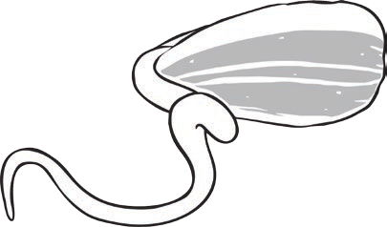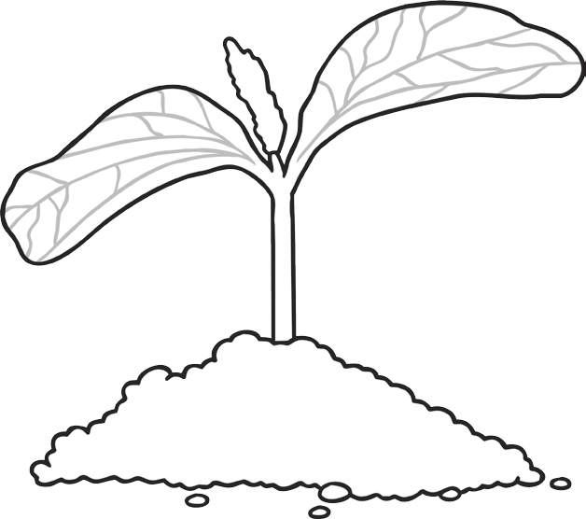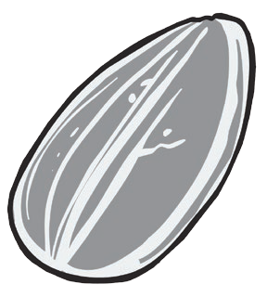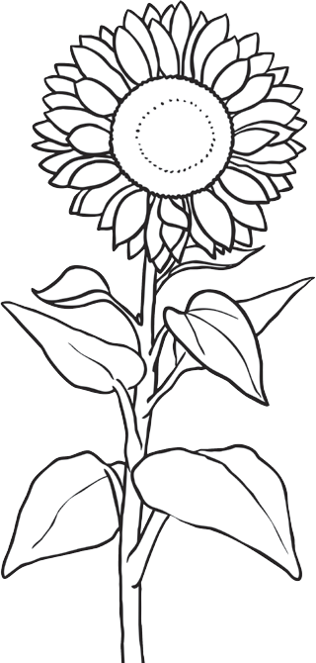

Design a shield



Shield examples

|  |  |  |
| --- | --- | --- |
|  |  |  |
|  |  |  |
|  |  |  |

Design a plant pot

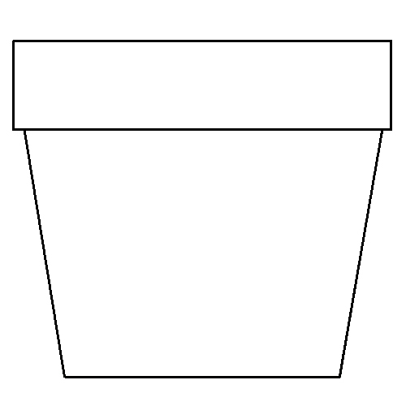

Remember to think about the size of the things you draw. Ladybirds and flowers are smaller than trees.

Design a new pair of socks for Sir Charlie Stinky Socks.

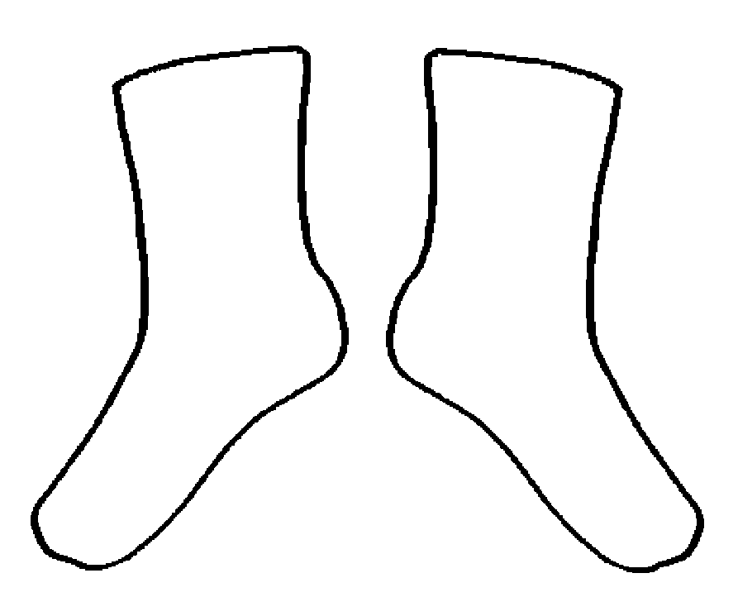

Label the parts of the castle

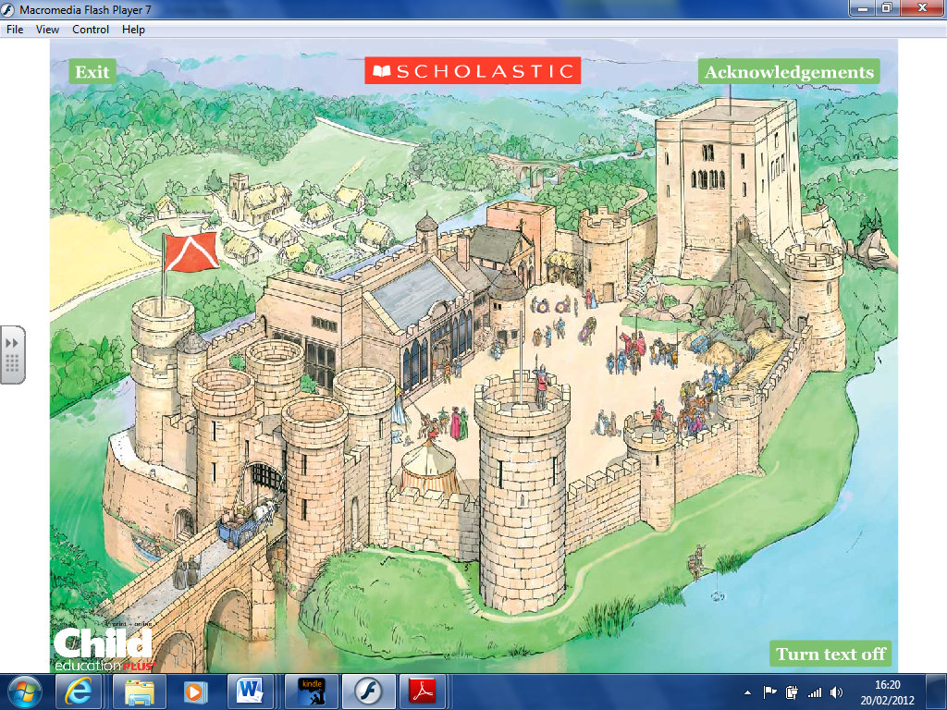

Word bank: Drawbridge Moat Tower Battlements Arrow loops