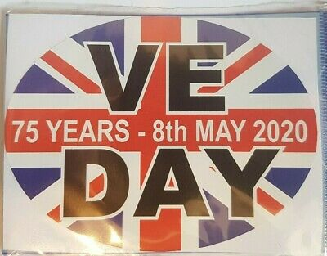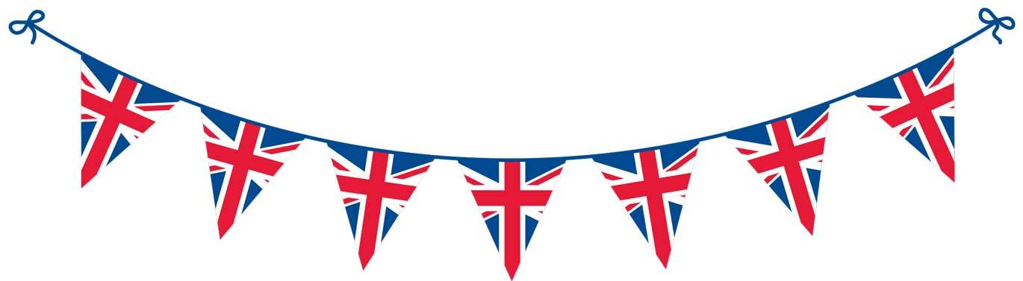

Wartime recipes - have a read of the different recipes. which one do you like the sound of. If you are feeling adventurous you might like to try one. Wartime Recipe booklet [www.twinkl.co.uk](http://www.twinkl.co.uk)

Send us some pictures if you do!

Make a poster.

Create a fact file.

Can you ask your grandparents if they can remember anything about VE day!

Could you make some Union Jack bunting to celebrate the victory? How else could you celebrate?

Have a look at the power point and activities. We hope you will try a few and learn something new about VE day.

Read the facts about VE day and see if you can answer the questions? KS1 VE Day Differentiated Reading Comprehension Activity

[www.twinkl.co.uk](http://www.twinkl.co.uk/)

What have you learnt?

**VE Day**

Project

Design a street party menu.

Write a postcard to a missing family member telling them about your VE day celebrations. Draw a picture on the other side to show what you did and what you saw.

Make a spitfire glider.