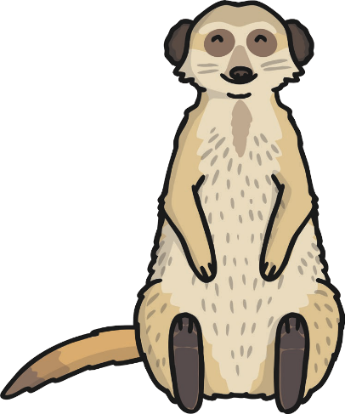
Year 2 African Safari Project

Mathematics Painting patterns
Look at different safari animal skin and fur patterns.
Maths Problems - Try the Safari themed KS1 challenge cards. Investigate how to draw or paint these textures.
Comparing numbers - Use the Safari themed Number
Comparison Sheet to practise using the arrow symbols, < and >.
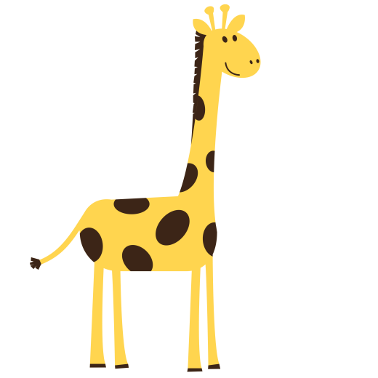
Science
www.twinkl.co.uk

Carnivore, herbivore or omnivore?
Why not try some African Animal Yoga Poses using
the African Animal Yoga Stories?

Sort the African animals into the correct group. What do meerkats
eat?
Hot and Cold Animal habitats Animal Matching Activity
Learn about where the animals live and what they need to survive.
Food chain Power Point
Learn about animal food chains. Can you create a African safari animal
English food chain?
Watch the Safari Video PowerPoint
www.twinkl.co.uk
Imagine what you would see, hear and smell if you were there
on safari. Safari vehicle
- Learn about meerkats using the Information PowerPoint. Design, make and evaluate a safari vehicle for transferring tourists
- Learn how to write a postcard using the Meerkat Postcard around the safari park.
Presentation and write a postcard using the template. .
Write an information sheet about meerkats using Geography
the Meerkat Non-Chronological Report Sheet. Find out where different safari animals live. Locate these places on maps and
Write a report, information leaflet or travel review for globes. Where do meerkats live?
tourists on safari.
Read the Safari Animal Fact File Posters together to help. Use the Go Jetters Continent of Africa PowerPoint to learn more about Africa
Read All about Africa and answer the questions. Research the weather conditions, culture and other wildlife.
Use the Guided Reading Pack linked to Geography in the form of a
Have a go at making an African Animal Mask or a Safari in a shoe box!
non-chronological report about Africa.

