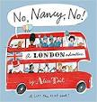
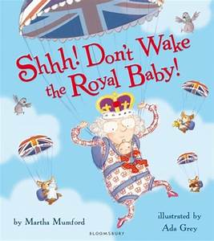
Spring Term 2023 Year 1 -
Miss Miller & Mrs Drayton

Our quality texts this term will be based around -
The Royal Family, London City and The Great Fire of London.
Communication, Language & Literacy
- Demonstrate an understanding of the text by answering questions related to who, what, how, why and where.
- Start sentences with a capital letter.
- Write in different forms with simple text type features, such as writing a postcard.
- Spell words containing each of the 40+ phonemes already taught.
- Continue to learn to read and spell the Year 1 tricky words.
- Form lower-case letters in the correct direction, starting and finishing in the right place and joining some letters correctly.
- Read their writing back and edit their work.
Mathematical Understanding
- Represent and use number bonds and related subtraction facts within 20.
- Add and subtract one-digit and two-digit numbers to 20, including zero.
- Solve one-step problems involving multiplication and division, by calculating the answer using concrete objects, pictorial representations and arrays with the support of the teacher.
- Recognise, find and name a quarter as one of four equal parts of an object, shape or quantity.
- Recognise, name and describe properties of 3D shapes.
Understanding Physical Health and Wellbeing
P.E days
Miss Miller’s class have PE on Wednesday and Thursday.
Mrs Drayton’s class have PE on Thursday and Friday.

Please ensure your child comes in their PE kit and wears their school jumper or cardigan. Thank you.
- Perform actions in a sequence.
- Recognize changes in my own body as I make movements.
- Stop a ball using hands or feet.
- Throw an object with one hand.
- Catch a ball with 2 hands.
- Take part in a team game.

Music
- Use their voices expressively and creatively by singing songs and speaking chants and rhymes, such as London’s Burning.
- Listen with concentration and understanding to a range of high-quality live and recorded music.

Scientific and Technological Understanding
- Use their observations and ideas to suggest answers to questions. Such as which material would make a good building materials.
- Distinguish between an object and the material from which it is made.
- Describe properties of materials.
- Perform simple tests. Such as exploring which materials would be waterproof.
Geography and History
- To learn about the life of Samuel Pepys.
- Sequence the events of The Great Fire of London.
- Recognise London landmarks.
- London Transport
- Learn about London as a capital city.
- Study the Royal Family.
RE
- To learn respect different beliefs.
- Compare Christianity to another faith.
- Study different celebrations.

Understanding the Arts and Design
- To use a range of materials creatively to design and make a felt brooch.
- Evaluate their ideas and products against design criteria.
- Create a portrait of Queen Elizabeth.
- Use fastening techniques to make a Tudor house.
- Explore techniques and materials to create a cityscape.

Computing
- Explore algorithms and their uses.
- Write algorithms (programs) for the beebots.
- Create simple code to control characters.
Books you might like to read at home too…
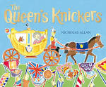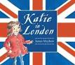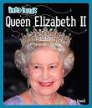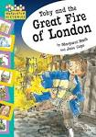

Reading Books
Phonics
This term your child will be learning some Phase 5 alternative pronunciations.
y making ee such as in funny
ea making e such as in head
wh making w such as in wheel
oe ou making oa such as in toe shoulder
y making igh such as in fly
ow making oa such as in snow
g making j such as in giant
ph making f such as in phone
le and al making l such as in apple metal
c making s such as in ice
ve making v such as in give
o-e ou making u such as in some mother young
se making z such as in cheese
se ce making s such as in mouse fence
ey making ee such as in donkey
ui ou making oo such as in fruit soup

Here is a QR code which will take you to a webpage which contains videos to help you/your child pronounce all the phonemes (sounds) correctly.
Reading at home is so important to help the children build on those skills they have been
taught at school and what better way to learn when they are finding it so pleasurable.
Please hear your child read 3 times a week and record this is their reading record.

Your child has two books:
- A reading practice book – Collins Big Cat (this book says Little Wandle on the cover) This book has been carefully chosen and matched to your child’s phonetic ability and will be at the correct phonic stage for your child. They should be able to read this fluently and independently. We encourage children to read this book three times.

- A sharing book. Your child may not be able to read this book on their own as it is not fully decodable and may not match their exact phonics level. This book is for you both to read and enjoy together.

