BUSHFIELD ROAD INFANT SCHOOL

COMPLAINTS
POLICY
July 2021

Introduction
Good relationships between schools, families and communities are important in supporting pupils to succeed, in terms of their social and emotional well-being and meeting or exceeding their predicted outcomes in academic achievement.

One mechanism for building good relationships is to encourage feedback on the services that school provides. Feedback can help to improve and develop practices and services provided by school. Encouraging feedback is one way to show those who work in partnership with schools that their views are valued.

Occasionally feedback on difficulties and challenges that arise will be received and these will need to be addressed to ensure that the supportive partnership continues. In many cases issues can be resolved informally. However, where there is an issue that cannot be concluded informally a formal procedure is required that will attempt to resolve and reconcile all parties concerned. Any person, including any parent /carer or member of the public are able to make a complaint.

What is a complaint?
A complaint may be defined as ‘an expression of dissatisfaction however made, about actions taken or a lack of action’ (DfE definition).

Schools need to be clear about the difference between a concern (managed at the informal stage) and a complaint. Taking informal concerns seriously at the earliest stage will reduce the numbers that develop into formal complaints.

A concern may be defined as ‘an expression of worry or doubt over an issue considered to be important for which reassurances are sought’ (DfE definition).
It is in everyone’s interest that complaints are resolved at the earliest possible stage.
Many issues can be resolved informally, without the need to invoke formal procedures. Bushfield Road Infant school takes informal concerns seriously and work to resolve any concerns quickly. We encourage parents to speak to the school before any issues or concerns escalate and an appointment can be made to meet with the class teacher or Head Teacher in private to discuss any concerns. We will always make an appointment to meet at the earliest opportunity.
General Principles
There is a duty on Schools to have in place a complaints procedure. (Section 29 of the Education Act 2002). Best practice Advice for School Complaints Procedures 2020 - updated January 2021 was utilised in the creation of this policy. Academies are also required to have a complaint procedure (The Education (Independent Schools Standards) Regulations 2010).

This procedure is intended to apply to general complaints that are received by school. However, some complaints are subject to statutory procedures.
These complaints are:

Delivery of the National Curriculum, religious education or collective worship (maintained schools) | Governors agreed complaints procedure applies but complainant has further right to approach the DfE at: www.education.gov.uk/contactus
Complaint by member of staff * | Grievance procedure - adopted by school/academy
Capability issues * | Capability procedure - adopted by school/academy
Pupil Exclusion * | Pupil Discipline procedure - DfE  guidancewww.gov.uk/school-discipline-exclusions/exclusions.
Admissions to school * | Dealt with via LA Admissions team
Matters likely to require a Child Protection Investigation | Complaints about child protection matters are handled under our child protection and safeguarding policy and in accordance with relevant statutory guidance.
Special Educations Needs | LA Procedures apply
Whistleblowing | We have an internal whistleblowing procedure for all our employees, including temporary staff and contractors.
Complaints about services provided by other providers who may use school premises or facilities | Providers should have their own complaints procedure to deal with complaints about service. Please contact them direct.

In schools where the Governing Body is the employer (Foundation, Voluntary Aided and Trust schools) complaints relating to * should be addressed to the school’s Governing body.

In dealing with any complaints:
- Any procedure should aim to balance the rights and responsibilities of pupils, parents and school staff and to recognise that responsibilities rest with each of these.
- The procedure should be easily accessible and well publicised.
- It should be impartial and non-adversarial.
- The procedure should have established time limits for action and keeping people informed.
- Confidentiality must be maintained at all times although all parties will need to accept that some information may need to be shared if the complaint is to be fully investigated.
- A complaint is not part of any staff disciplinary process and staff who may be interviewed as part of the investigation must be treated fairly and have an opportunity to state their case. Staff should be offered support in dealing with any investigation into a complaint.
- Any member of staff who is complained about will have the opportunity to respond to the complaint during the investigation and will be able to see any response as a result of the investigation. Any disciplinary procedures that may arise from the investigation will be dealt with separately under the school’s disciplinary procedure.
- A complaint about a member of the Governing Body will be dealt with under the Dealing with Complaints against Governors policy.

Resolving Complaints
At each stage of the procedure we will keep in mind ways in which a complaint can be resolved. It might be sufficient to acknowledge that the complaint is valid in whole or in part. In addition, it may be appropriate to offer one or more of the following:
- an apology
- an explanation
- an admission that the situation could have been handled differently or better (an admission that the school could have handled the situation better is not the same as an admission of negligence)
- an assurance that the event complained of will not recur
- an explanation of the steps that have been taken to ensure that it will not happen again
- an undertaking to review school policies in light of the complaint.

Stage One - Informal Concerns
1.1 Any parent/carer/or member of the public who has a concern should make contact with the appropriate member of staff who should clarify the nature of the concern/complaint and reassure them that the school wants to hear about it. This would usually be the teacher or may be the Head teacher, Mrs T Bass. If the member of staff cannot deal with the matter immediately, they should make a clear note of the date, name and contact details of the complainant and agree a convenient time to make contact.

1.2 The member of staff should record details of the concern and try to identify what action/outcome the parent/carer is looking for. (See Appendix A).

1.3 If no satisfactory solution has been found within 10 working days the complainant should be asked if they wish their concerns to be considered further. If that is the case and matter has previously been dealt with by a teacher/ member of staff then the next stage, Stage 2, should be dealt with by the Head teacher. If the informal stage was dealt with by the Head teacher the Stage 2 contact should be the Chair of Governors.

Stage Two - Formal Consideration by Head teacher or Chair of Governors

2.1 It should be the aim of all concerned to reach an agreed solution to the problem at this stage for the good of the child, parents/carer/complainant and the school.
2.2 Stage 2 complaints should be made in writing where possible (Appendix B) although, in line with the Equalities Act, access arrangements should be made to allow a complaint to be made depending on their circumstances. The complaint should be made within two months of the incident occurring, to be considered. Complaints made after this time may be considered in exceptional circumstances.
2.3 The complaint should be acknowledged within 5 working days of receipt. The written acknowledgement should give a brief explanation of the school’s General Complaints Procedure/ direct the complainant to the policy on the website and a target date for providing a response to the complaint. This will normally be within 15 working days. If this proves impossible, communication will be sent explaining the reason for the delay and giving a revised target date. Where the complaint at Stage 2 is against the Head teacher the investigation should be conducted by a single governor (usually the Chair of Governors or the Vice Chair).
2.4 It should be made clear in the acknowledgement that the substance of the complaint will be shared with any staff implicated and some information will be shared, when necessary, with other parties as part of the investigation process.
The Head teacher (or Governor) should provide an opportunity for the complainant to provide any further information relevant to the complaint. Depending on the reason for the complaint, statements from witnesses may be required. The Head teacher (or Governor) should keep written records of meetings, telephone conversations and other documentation used as part of the investigation. It should be explained to complainants that the school will only consider recordings of conversations or meetings if there is signed consent from all participants of the conversation/meeting.

2.5 If the complaint centres on a pupil, the pupil may also be interviewed depending on the nature of the complaint, the age of the child and appropriateness of asking questions of the child. It is good practice that, when pupils are interviewed in a formal situation, the children’s parents are present. If this is not possible then a member of staff who is known and trusted by the pupil should be invited to attend.

2.6 When all the relevant facts have been established, the Head teacher (or Governor) should produce a written response to the complainant. The written response should include a full explanation of the outcome and the reasons for it. Where appropriate, this should include any action the school will take to resolve the complaint. The complainant should be advised that if they wish to take the matter further, they should notify the Chair of the Governing Body within 10 working days of receiving the outcome letter. If the complaint is not resolved at this level, the complainant will be given the option to move to Stage 3.

2.7 If the complaint is:
• jointly about the Chair and Vice Chair or
• the entire governing body or
• the majority of the governing body
Stage 2 will be considered by an independent investigator arranged via the Clerk. At the conclusion of their investigation, the independent investigator will provide a formal written response. This will be considered at Stage 3.

Before progressing the complaint to Stage 3, it would normally be expected that the complainant has:
- sought to resolve the concern/complaint through approaches to the school as described in Stages 1 and 2
- allowed reasonable time for investigation of the concern
- accepted any reasonable offer by the school to discuss the result of the investigation
- taken part in any process of mediation offered by the school
- made the initial complaint within two months of the incident occurring

Stage Three - Referral to the Complaints Committee of the Governing Body

3.1.1 Complaints rarely reach this stage, but Governing Bodies should be prepared to deal with them when necessary.
3.1.2 The Governors who will hear the Complaint Appeal should have no prior knowledge or previous involvement with the complaint. This is to ensure the appeal is both independent and impartial to stop any prejudice of the appeal. Therefore it is very important that discussion about the complaint does not take place outside of the Complaints Committee meeting.

3.1.3 As this may be the last chance for a solution or compromise to be reached, every effort should be made to reach agreement through reconciliation or mediation.

3.1.4 All Complaint Appeals should be received in writing, wherever possible, subject to Equality considerations.

3.1.5 It is important that the Complaints Committee views the complaint as being against the school rather than an individual staff member whose actions may have led to the original complaint.

Stage Three Procedure
Option One – Consideration by the Complaints Panel
Upon receipt of a written request by the complainant for the complaint to proceed to Stage 3, the procedures outlined below should be followed:

3.2.1 The Chair of the Governing Body or the Governing Body Clerk should write to the complainant to acknowledge receipt of the written request within 5 working days. The acknowledgement should inform the complainant that a meeting of the Governing Body’s Complaints committee would be convened, to hear the complaint within 15 working days.

3.2.2 The Clerk to the Governing Body should convene a Complaints Panel within the agreed timescale. The panel should consist of at least 3 governors who have not previously been involved in dealing with the complaint. (For an academy complaint panel, at least one member must be independent of the management and running of the school). The Head teacher should not be a member of the panel. The Clerk should be responsible for making all the arrangements for the meeting, including the time and place. The complainant, Head teacher, any relevant witnesses and members of the Complaints Panel should be informed at least 5 working days in advance of the date, time and place of the meeting. The notification to the complainant should also inform them of their right to be accompanied to the meeting by a friend/advocate/interpreter. The letter should also explain how the meeting would be conducted.

3.2.3 The Head teacher should be invited to attend the Complaints Panel meeting and to prepare a written report for the Panel in response to the complaint. If the complaint is about the Head teacher it will be the Chair who will respond to the complaint. Any relevant documents, including the Head teacher’s/Chair’s report, and any documentation supplied by the complainant should be received by all concerned, including the complainant, at least 5 days prior to the meeting. The committee should elect a Chair for the meeting. The Governing Body should have regard to the need for diversity on the panel ensuring representation for the need of the complaint where possible. The meeting should be appropriately minuted.

3.2.4 The aim of the meeting should be to resolve the complaint and achieve reconciliation between the school and the complainant. The Panel should try to ensure that the meeting is not too formal or intimidating for those involved. All should be told the names of everyone present and have the procedure explained to them at the beginning of the meeting.

3.2.5 The meeting should allow:

- The complainant1 to explain their complaint/s and the Head teacher/Chair of Governors to explain the school’s response.
- Panel members to have an opportunity to question the complainant, the Head teacher and any witnesses, as appropriate.
- Final statements by both the Head teacher/ Chair of Governors and the complainant. (Procedure for Complaint Hearing Appendix C)

3.2.6 The Chair of the Panel should explain to the complainant and the Head teacher that the Panel will now consider its decision, and that a written decision will be sent to both parties within 5 working days. The complainant, Head teacher and other members of staff and witnesses should leave the meeting.

3.2.7 The Panel should then consider the complaint and all the evidence presented in the presence of the Clerk and:
a) reach a majority decision on the complaint;
b) decide upon the appropriate action to be taken to resolve the complaint;
c) where appropriate, recommend changes to the school’s systems or procedures to ensure that problems of a similar nature do not happen again. Recommendations should be reported to the Governing Body at an appropriate time;
d) where appropriate to do so, recommend any further action

1 The complainant may allow a friend, relative or advocate to speak on their behalf
3.2.8 The Clerk to the Governing Body should send the complainant, the Head teacher and Chair of Governors a written statement outlining the decision of the committee within 7 working days of the meeting.

3.2.9 Copies of all correspondence should be kept on file in the Governors records. These records should be kept separately from pupil’s personal records.

Option Two - Investigation by an Independent Person on Behalf of the Governing Body

3.3.1 There may be occasions when the Governing Body of a school will ask (or be advised to ask) an independent person to investigate a complaint on their behalf.

3.3.2 The Independent Person will carry out the investigation on a repayment basis on behalf of the Governing Body.

3.3.3 The investigation will be carried out within an agreed timescale (normally 25 working days). The aim of the investigation should be to establish all the facts, with the goal that the complaint be resolved and reconciliation achieved between the school and the complainant.

3.3.4 The complainant and the Head teacher/Principal /Chair of Governors will be given an opportunity to make representations to the investigating officer. It will not be possible to introduce new evidence at this stage of the proceedings. Depending on the reason for the complaint, statements from witnesses may be required.

3.3.5 The Independent Person will prepare a written report to the Complaints Panel of the Governing Body on the outcome of the investigation.

3.3.6 Copies of the report would also be made available to both the Head teacher and the complainant at least 5 days prior to the meeting of the Complaints Panel of the Governing Body to which they should be invited to attend. The Complaint Panel will be convened in the same way as it would be if it was considering the complaint, to consider the report.
3.3.7 The Complaints Panel should be informed at least 5 working days in advance of the date, time and place of the meeting and should also receive the report in this time scale. The meeting should be appropriately minuted.

3.3.8 At the meeting the Panel should consider the complaint and the report presented by the Independent Person. As no further evidence can be presented at this stage the Head teacher/Principal/Chair of Governors and Complainant are there as observers and for verification purposes only.

3.3.9 The Chair of the Panel should explain to the complainant and the Head teacher that the Panel will now consider its response, and that a written response will be sent to both parties within 7 working days. The Complainant and Head teacher should then be asked to leave. The process should continue as per the Complaint Panel procedure - 3.2.6i, in that the Panel:

a) decide upon the appropriate action to be taken to resolve the complaint;
b) where appropriate, recommend changes to the school’s systems or procedures to ensure that problems of a similar nature do not happen again. Recommendations should be reported to the Governing Body at an appropriate time;
c) where appropriate to do so, recommend any further action.

3.3.10 The Clerk to the Governing Body should send the complainant, the Head teacher and Chair of Governors and, where relevant, the person complained about a written statement outlining the decision of the committee within 7 working days of the meeting

3.3.11 Copies of all correspondence should be kept on file in the Governors records. These records should be kept separately from a pupil’s personal records if the complaint centred around a specific pupil or pupils.
Further Action
Stage Four – Secretary of State (via the Department for Education)

The complainant may approach the Secretary of State for Education via the DfE, on the grounds that a governing body has acted or is proposing to act unreasonably, or that the Governing Body or LA has failed to discharge its duties under legislation. Complaints of this nature rarely succeed, however, providing that all procedures have been followed correctly. Where complaints are made, the Secretary of State may contact the Governing Body or the LA for more information.

For complaints relating to an academy the next stage would be to approach the Education Skills and Funding Agency who deal with complaints against academies on behalf of the DfE. Again they will only investigate that the policy has been followed correctly, they will not reinvestigate the complaint.

The link below accesses the DfE contact form for both maintained schools and academies:
https://www.education.gov.uk/form/school-complaints-form

Unreasonably Persistent or Vexatious Complainants
The great majority of people with complaints or concerns about the school behave reasonably in pursuing their complaint. This means that they:
• treat all school staff with courtesy and respect;
• respect the needs of pupils and staff within the school;
• avoid the use of violence (including threats of violence) towards people and property;
• recognise the time constraints under which members of staff work and allow the school a reasonable time to respond to a complaint;
• recognise that resolving a specific problem can sometimes take some time;
• follow the school’s complaints procedures.

However, a small number of complainants may be deemed “unreasonably persistent or vexatious complainants”. This means that, in complaining about issues, either formally or informally, they behave unreasonably, for example by:
• actions which are obsessive, persistent, harassing, prolific, repetitious; and/or
• prolific correspondence or excessive e-mail or telephone contact about a concern or complaint; and/or
• an insistence upon pursuing unmeritorious complaints and/or unrealistic or unreasonable outcomes; and/or
• an insistence upon pursuing meritorious complaints in an unreasonable manner.
• cause harassment to the staff.

A model procedure for identifying and responding to such complainants or persons causing harassment to the staff is attached as Appendix D.

Parent Support
Free and independent advice for Parents is available through the Advisory Centre for Education (ACE). ACE is a National Charity which aims to provide the information, support and high-quality advice that parents need to help their children at school, particularly where there are problems.

The telephone number for ACE is 0300 0115 142
The web address is: http://www.ace-ed.org.uk/
Free and independent advice for Parents is also available through the Corum Children’s Legal Service.
https://www.childrenslegalcentre.com/get-legal-advice/education/

Dealing with Complaints in Exceptional circumstances

The time frames outlined within this policy may be amended in line with DfE guidance due to exceptional circumstances, such as Covid. This may also mean that any panel meetings may need to be held virtually, where possible, to ensure the safety of all parties.

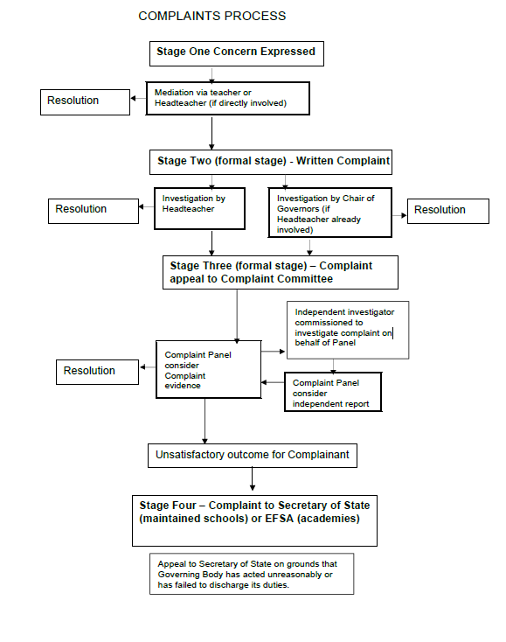
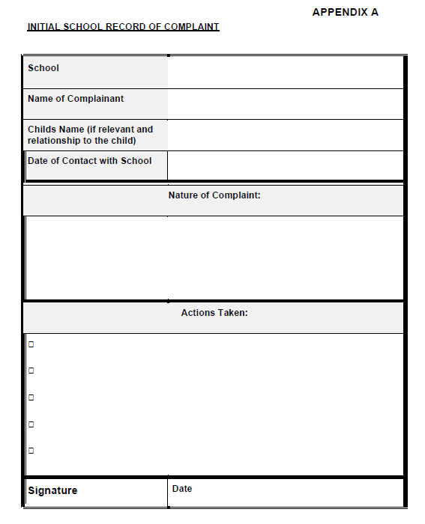

Complainant Form Appendix B
Please complete and return to the Head teacher who will acknowledge receipt and explain what action will be taken.

Your name:

Pupil’s name:

Your relationship to the pupil:

Address:

Postcode:

Day time telephone number:

Evening telephone number:

Please give details of your complaint:

What action, if any, have you already taken to try and resolve your complaint. (Who did you speak to and what was the response)?

What actions do you feel might resolve the problem at this stage?

Are you attaching any paperwork? If so, please give details.

Signature: Date:
Official use

Date acknowledgement sent: By who:

Complaint referred to: Date:

Appendix C
A Model Procedure for the Conduct of a Complaint Hearing at Stage Three
1. The Clerk for the meeting should invite everybody into the room, introduce them and explain the role of each person.

2. The Chair should explain to all present that the purpose of the meeting is to review the complaint, resolve any differences and achieve a reconciliation between the school and the complainant.

3. The Chair should then outline the proposed procedure for the meeting. S/he should listen to any concerns about the procedure but has the final decision about the arrangements:

(a) The complainant will outline the complaint and may call witnesses.

(b) The Head teacher will be given the opportunity to seek clarification from the complainant and/or witnesses.

(c) The Panel may seek clarification from the complainant and/or witnesses.

(d) The Head teacher will be given the opportunity to respond and call witnesses.

(e) The complainant will be given the opportunity to seek clarification from the head teacher and/or witnesses.

(f) The Panel will seek clarification from the complainant and/or witnesses.

(g) The complainant will be given the opportunity to sum up.

(h) The Head teacher will be given the opportunity to sum up.

(i) Both parties will then leave the room to allow the committee to deliberate. Any LA representative may remain to offer technical and/or procedural advice.

4. The committee will then arrive at its decision. This will cover:

- Findings on the complaint.

- Appropriate action to be taken by the school.

- Any recommended changes to the school’s systems or procedures.

5. The decision will be notified to all parties, in writing, within 7 school days.
Appendix D
Procedure for Dealing with Unreasonably Persistent or Vexatious Complainants or Persons that Cause Harassment of the School staff.

Introduction
1. The great majority of people with complaints or concerns about the school behave reasonably in pursuing their complaint. This means that they:

• treat all school staff with courtesy and respect
• respect the needs of pupils and staff within the school
• avoid any use, or threatened use, of violence to people or property
• avoid any aggression or verbal abuse
• recognise the time constraints under which members of staff work and allow the school a reasonable time to respond to a complaint
• recognise that resolving a specific problem can sometimes take some time
• follow the school’s complaints procedures.

2. However, this appendix to the Model Complaints Procedure for Schools deals with complainants that are unreasonably persistent or vexatious or persons that harass the school staff/ school community.

Definitions
3. For the purposes of this appendix, an “unreasonably persistent or vexatious complainant” is defined as follows:

An unreasonably persistent complainant is a person who complains about issues, either formally or informally, or frequently raises issues that they consider to be within the remit of the school and whose behaviour is unreasonable, including harassment. Such behaviour may be characterised by:

• actions which are obsessive, persistent, harassing, prolific, repetitious
• refuses to articulate their complaint or specify the grounds of a complaint or the outcomes sought by raising the complaint, despite offers of assistance
• refuses to co-operate with the complaints investigation process
• refuses to accept that certain issues are not within the scope of the complaints procedure
• insists on the complaint being dealt with in ways which are incompatible with the complaints procedure or with good practice
• introduces trivial or irrelevant information which they expect to be taken into account and commented on

- raises large numbers of detailed but unimportant questions, and insists they are fully answered, often immediately and to their own timescales
- makes unjustified complaints about staff who are trying to deal with the issues, and seeks to have them replaced
- changes the basis of the complaint as the investigation proceeds
- repeatedly makes the same complaint (despite previous investigations or responses concluding that the complaint is groundless or has been addressed)
- refuses to accept the findings of the investigation into that complaint where the school’s complaint procedure has been fully and properly implemented and completed including referral to the Department for Education
- seeks an unrealistic outcome
- makes excessive demands on school time by frequent, lengthy and complicated contact with staff regarding the complaint in person, in writing, by email and by telephone while the complaint is being dealt with
- uses threats to intimidate
- uses abusive, offensive or discriminatory language or violence
- knowingly provides falsified information
- Publishes unacceptable information on social media or other public forums.

Harassment is defined in this policy as the unreasonable pursuit of such actions as in such a way that they:

• appear to be targeted over a significant period of time on one or more members of school staff and/or;
• cause on-going distress to individual member(s) of school staff and/or;
• have a significant adverse effect on the whole/parts of the school community and/or;
• are pursued in a manner which can be perceived as intimidating and oppressive by the recipient. This could include situations where persistent demands and criticisms, whilst not particularly taxing or serious when viewed in isolation, have a cumulative effect over time of undermining confidence, well-being and health.

Deciding whether a complainant should be deemed an unreasonably persistent complainant or there is a case for harassment
4. Only the Head teacher, with the agreement of the Chair of Governors, may deem a complainant an unreasonably persistent complainant or whether there is a case for harassment.

5. The Head teacher will ensure that there is sufficient evidence available to justify the decision. They will consult the Authority’s Legal Services (maintained schools only) to confirm that the evidence is sufficient.

Action to be taken where a complainant is deemed an “unreasonably persistent complainant or causing harassment
6. In the first instance the school will write to the complainant that their behaviour is considered to be becoming unreasonable / unacceptable and, if it is not modified, action may be taken in accordance with this policy

7. If the behaviour is not modified the school will take some or all of the following actions as necessary, having regard to the nature of the behaviour and the effect of this on the school community. The Headteacher will write to the complainant/ party involved to explain the decision and the way that future complaints or interactions with the person will be dealt with. Any restrictions imposed will be appropriate and proportionate.

8. Some or all of the following actions may be taken, depending on the particular circumstances of the case:

• insisting that no member of staff should meet the complainant on his/her own;
• restricting telephone calls from the complainant to specified days and times;
• requiring that all future contacts with the school are in writing, including via email, except in emergencies; this includes contacts with members of the governing body, who should only be contacted at the school address;
• merely acknowledging correspondence from the complainant that raises issues that have already been dealt with;
• banning the complainant from the school premises where the complainant’s behaviour constitutes a nuisance or disturbance, with any appointments with staff to be agreed in writing by the Head teacher.

9. The school will take into account all equality access considerations when considering their action.

10. Any actions taken will include an indicative timescale for the duration of the sanction and the mechanism for when and how this will be reviewed.

11. However, all correspondence from the complainant will be considered and any new and substantive issues will be addressed and a reply sent to the complainant.

12. New complaints from people who have been deemed unreasonably persistent complainants will be treated on their merits.

