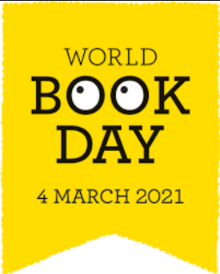
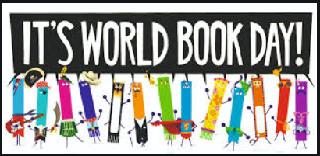
Celebrating World Book Day
Reading for pleasure is at the heart of World Book Day. We know that making every day a book day can have a significant impact on children and young people’s wellbeing. Three in five (59.3%) children and young people said that during the first lockdown, reading made them feel better (The National Literacy Trust). It shows just how important it is to encourage children to read for pleasure during these very difficult times. We would like to invite you to join us in helping your child to make the most of this day.
This year’s World Book Day theme is ‘share a story’. If you are learning from home, we would like you to encourage your child to share a favourite story with the people they live with. This could include getting grandparents or other family members to read stories over video chat; setting aside a family reading time when everyone at home all read their own books or magazines; building a cosy reading den with cushions in a corner, or a sheet draped over chairs to make a tent; read a story or chapter and then act it out together.
For Reception and Years 1&2, ‘Share a Story Corner’ develops confidence in reading together as a family at home. You can watch a selection of video books, from classic fairy tales to funny rhymes and enjoy the fun downloadable activities available for every story: www.worldbookday.com/share-a-story-corner
In addition, we are setting a special reading challenge ‘Are you a share a story reading star?’ Tick off a reading star each time you complete a reading task and have fun trying to reach all the stars! You can upload any photos onto our MS Teams Learning Platform or bring them into school by March 28th, so that everyone can share in the fun! There will be a prize for the most imaginative and interesting completed star! You can also play online and download your certificate when you’ve finished at www.worldbookday.com/reading-stars
Children at school should bring in their favourite story from home on Thursday 4th March so that they can read it throughout the day. Whenever they hear the music play, we will encourage children to stop whatever they are doing and begin reading their book. It could happen at any point during the day! Children can borrow a book from class if they cannot bring one in from home. We have lots of other exciting activities planned for the day!
A brand new selection of brilliant FREE audiobooks will be available for World Book Day 2021. Use audiobooks to bring life and depth to children’s reading experience, to encourage all readers, regardless of ability, to access and share the incredible world of stories. Available from worldbookday.com/world-of-stories until 28th March 2021.

Every child will receive a £1 book token. The book token is valid from Thursday 18 February – Sunday 28 March 2021. Participating booksellers will honour the tokens beyond the 28th March while stocks last. Tokens can be exchanged for any of the £1 books on offer (see the full line-up at worldbookday.com/books/) OR for getting £1 off any book or audiobook costing £2.99 or more in participating bookshops and supermarkets.
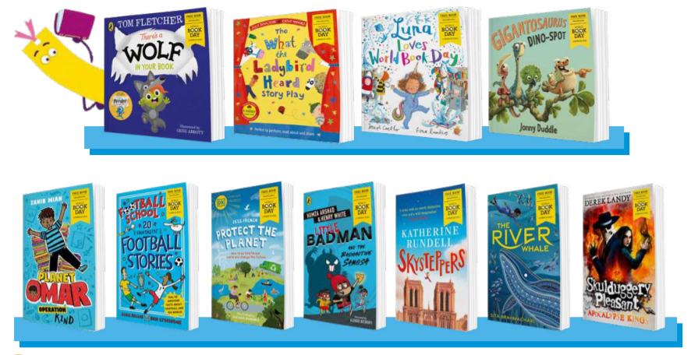
We hope you enjoy World Book Day 2021!
Did you know?
Reading for pleasure is the single biggest indicator of a child's future success, more than family circumstances, parents’ educational backgrounds or income. - Organisation for Economic Co-Operation & Development

